# Coursework 2 Part 2 Report

# Description

Coursework 2 Part 2 Report

Description

According to the results of data analysis, we can get the following information:

● Image sizes vary

● Some images are RGB channels, some images are single channel

● The data of different categories are evenly distributed

● The data similarity of the same category is high, such as seagull

According to this information, we can do some data preprocessing operations

● Cut the pixel size to 256 * 256

● Convert all channels of the image to RGB channels

● Increase noise

● Gamma transformation

● Image rotation

● Histogram equalization

# Image clipping and channel conversion

In most image classification networks, the sample size must be unified before it is input into the network, so a large amount of data can be expanded by adjusting the size of the image.

Based on the previous data analysis, next we need to complete the data preprocessing part. First, view the folder names of all bird categories under the current path, and arrange them in order.

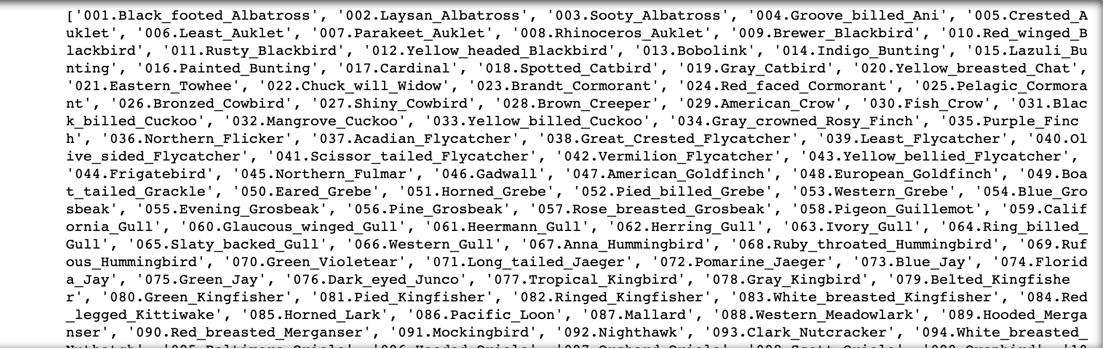

Secondly, read all the bird images under each category, and check the pixel size and channel of the image.

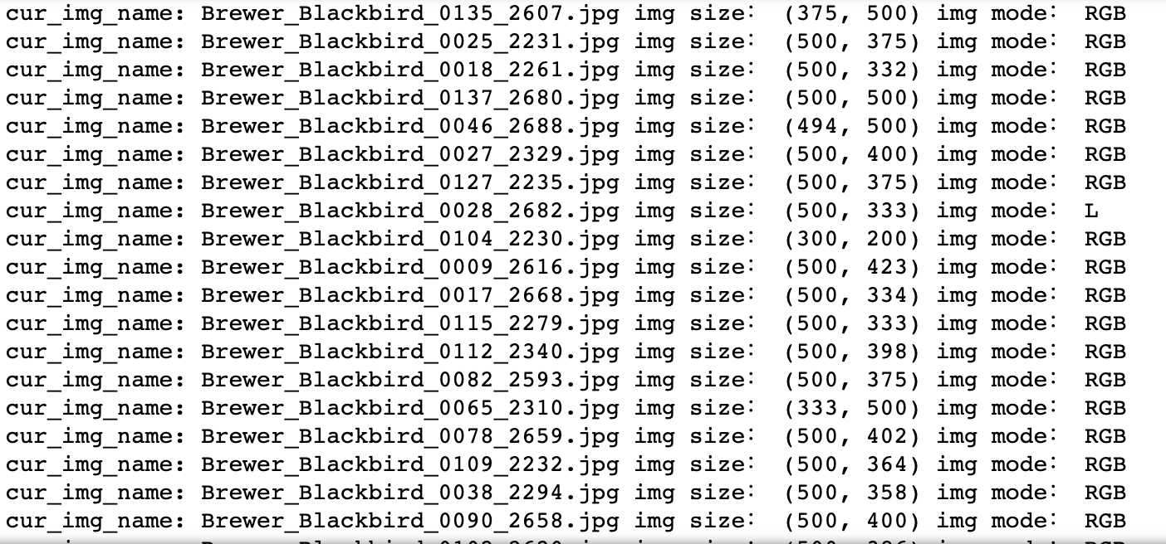

We find that the pixel size of each image is basically different, and different pixel size has a great impact on the subsequent model training, so we consider setting the data pixel size to a fixed value.

In addition, when we look at 009. Brewer_ When I read all the images in the blackbird folder, I found that not all the images are RGB channels, brewer_ Blackbird_ 0028_ 2682.jpg has only one channel, that is, L. Therefore, we consider converting other images that are not RGB channels into RGB channels, which is also for the convenience of later model training.

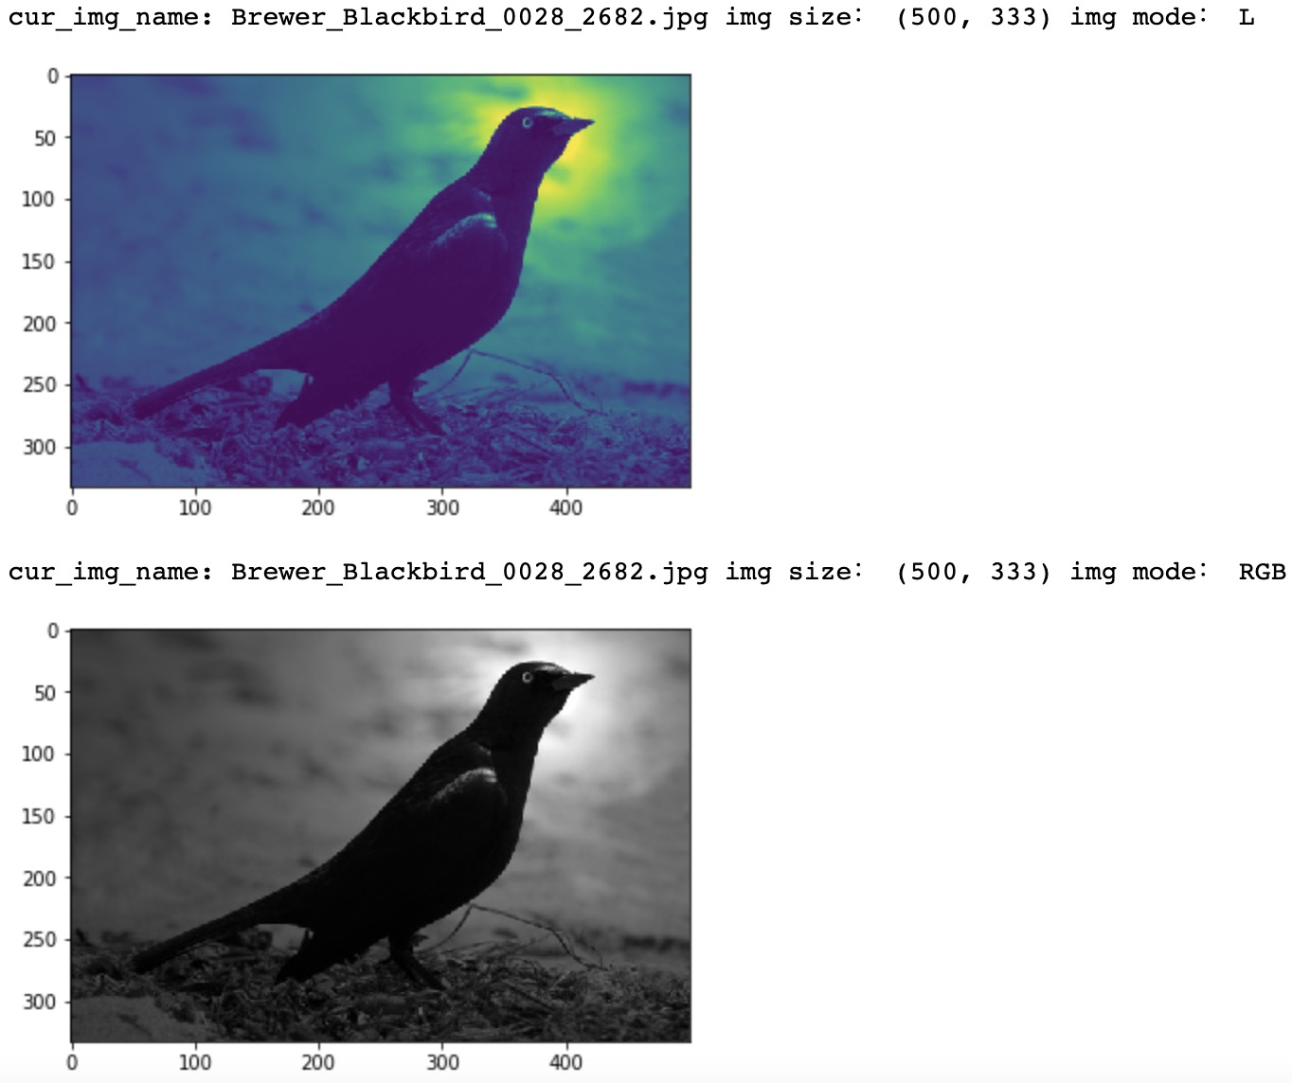

When we're done, we'll look at the image channel again and visualize it. It is found that the image has been converted. Through visualization, it can be found that the image has been converted to RGB image.

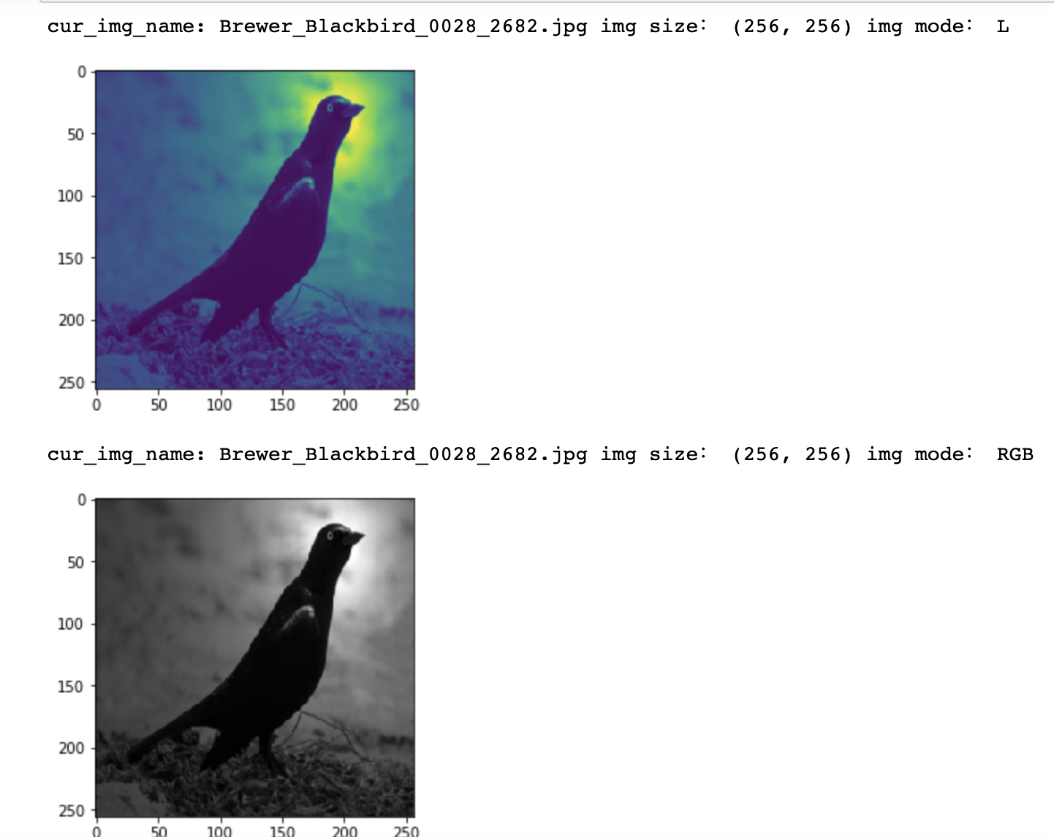

We convert all images to (256256) size, and all images are unified to that size. From the visual image coordinates, our size conversion has been completed.

So far, the preprocessing of image pixel and channel has been finished. The main task is to convert all images into a uniform size. And convert the non RGB channel image into RGB channel, all these work are for the later model training.

# Increase noise

When neural networks try to learn high-frequency features that may be useless (i.e. a large number of patterns in the image), over fitting usually occurs. Adding an appropriate amount of noise can enhance the learning ability.

Data enhancement based on noise is to add some noise randomly on the basis of the original image. Here, we convert the pixel values of some random pixels in the image to 255. As can be seen from the visual image, the image above is the original image, and the image below is the image that has been noisy.

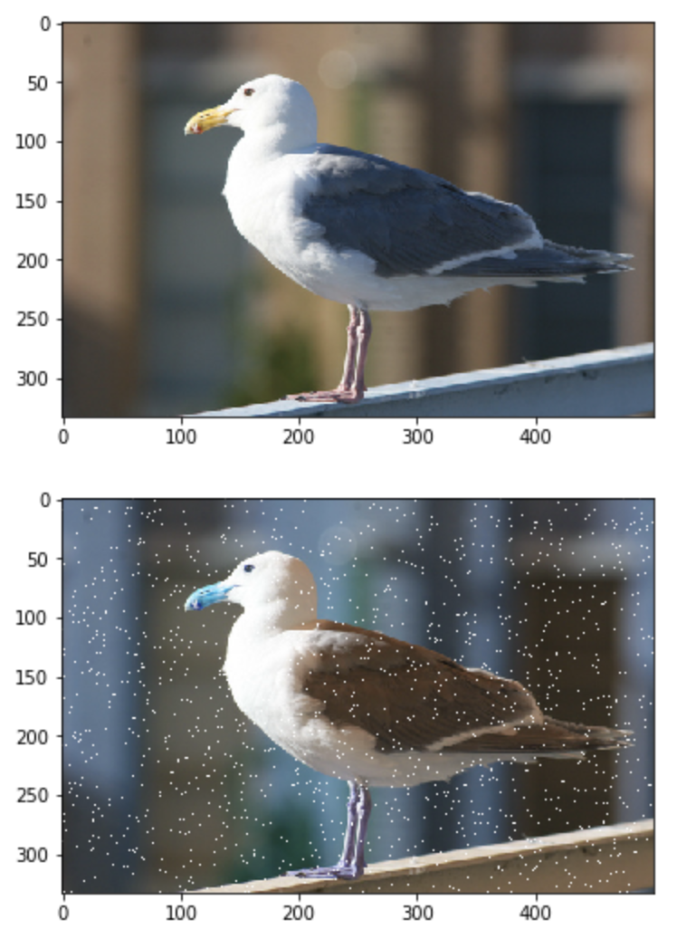

When we look at the dataset, we find that there are several types of gulls in the dataset：

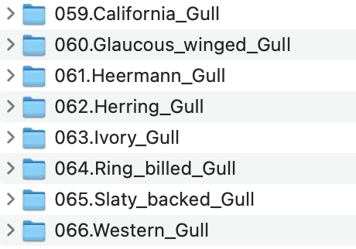

In order to distinguish different kinds of seagulls, it is not enough to only increase the noise, so we use more data enhancement methods to process the image, so that the similarity of different kinds of seagulls is smaller.

# Gamma transformation

In image processing, gamma transform is often used to adjust the contrast of over exposed or underexposed gray images. Specifically, through nonlinear transformation, the gray value of the darker area in the image is enhanced, and the gray value of the higher area in the image is reduced. After gamma transformation, the overall details of the image will be enhanced.

As can be seen from the figure below, the image after gamma transformation below has higher contrast than the original image.

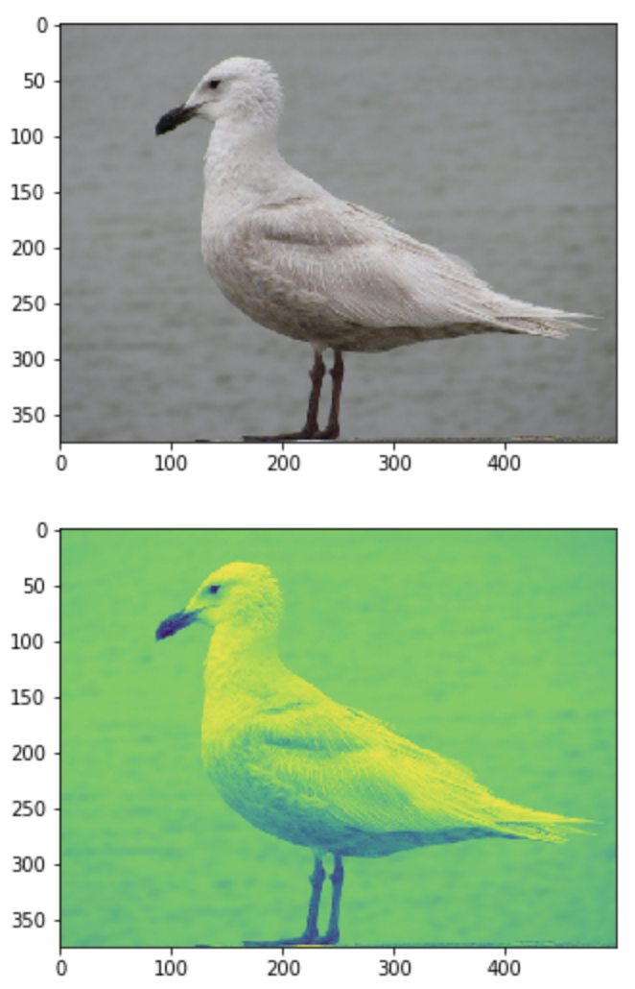

# Rotate

Rotation is to transform the original image pixel in the position space, and the rotation operation is mainly to transform the arbitrary angle along the center of the picture. The transformation is realized by multiplying the original image and the affine transformation matrix. In order to achieve the image center rotation, in addition to knowing the rotation angle, we also need to calculate the amount of translation, so that the effect of affine transformation is equivalent to the image center of the rotation axis.

Here, our method is to rotate the image 180 degrees. As can be seen from the figure, the image has reached the effect of rotation.

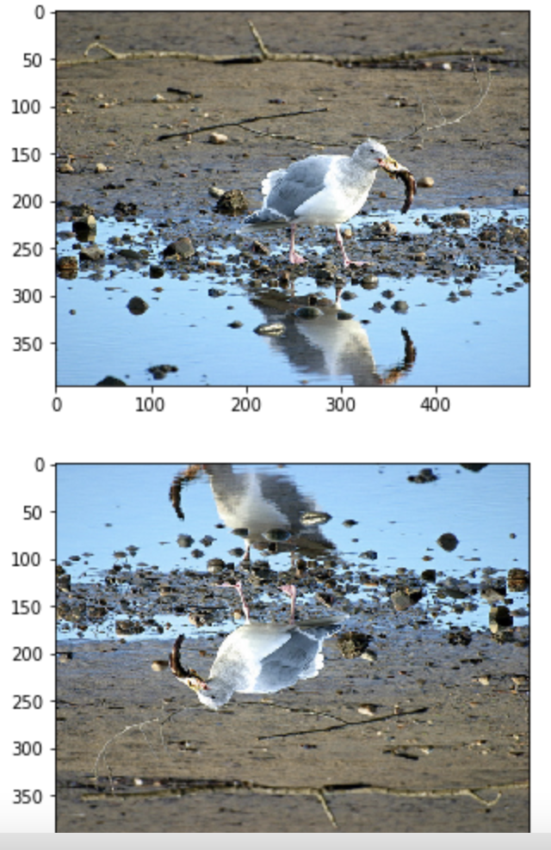

# Histogram Equalization

Contrast is the ratio of black to white, that is, the gradient from black to white. The larger the ratio, the more gradients from black to white, and the richer the color performance. Generally speaking, the larger the contrast is, the clearer the image is, and the brighter the color is; The small contrast will make the whole picture gray.

High contrast is very helpful to the definition, detail and gray level of the image. Contrast has a greater impact on the dynamic video display effect. Because the light dark conversion in dynamic images is faster, the higher the contrast, the easier it is for human eyes to distinguish such conversion process. High contrast products have more obvious advantages in detail performance, clarity and performance of high-speed moving objects in some dark scenes.

Histogram equalization is a method to enhance image contrast. The main idea is to change the histogram distribution of the image into approximately uniform distribution, so as to enhance the contrast of the image. Although histogram equalization is only the basic method of digital image processing, it is a classic algorithm.

We use histogram equalization enhancement method, first calculate the gray histogram, then calculate the accumulated gray histogram, finally get the mapping relationship according to the first two steps, and finally output the gray pixel value. The effect is shown in the figure below.

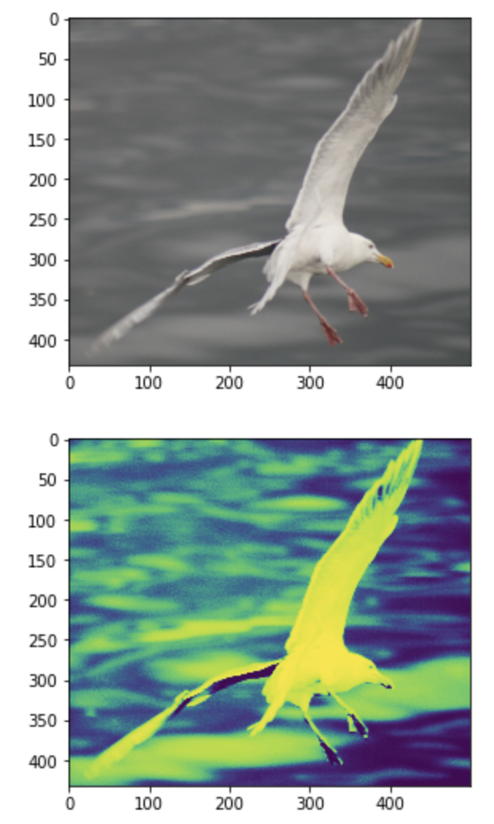

All the above image processing methods have implemented the corresponding interface, which can be called directly. For seagull data, we can use a variety of data enhancement methods to achieve small similarity between classes. In order to identify different types of gulls more clearly in the follow-up model.